

Product Dissection for SWIGGY

Company Overview:

Swiggy is one of India’s leading online food delivery and quick commerce companies, founded in 2014 by Sriharsha Majety, Nandan Reddy, and Rahul Jaimini, with its headquarters located in Bengaluru. The company provides an online platform that connects customers with restaurants and delivery partners, allowing users to order food, groceries, and other daily essentials conveniently through mobile applications and websites. Swiggy is known for its fast delivery services, real-time order tracking, multiple payment options, restaurant ratings and reviews, and customer-friendly interface. Over the years, the company has expanded its services through offerings such as Instamart, Dineout, and Genie, becoming a major player in India’s digital commerce and food delivery industry.

Product Dissection and Real-World Problems Solved by Swiggy:
Swiggy is a digital food delivery and quick commerce platform that connects customers, restaurants, and delivery partners through a single online system. The platform allows users to browse restaurants, explore menus, place food orders, make online payments, and track deliveries in real time. Swiggy also provides additional services such as Instamart for grocery delivery, Dineout for restaurant bookings, and Genie for pickup and drop services. Through its mobile application and website, the company offers a fast, convenient, and user-friendly experience for customers across many cities in India.
Swiggy solves several real-world problems by reducing the need for people to travel to restaurants and helping users save time and effort, especially busy students and working professionals. The platform supports cashless and contactless transactions through multiple payment methods and provides quick access to food and daily essentials from nearby stores and restaurants. It also helps restaurants increase their customer reach and creates employment opportunities for delivery partners. Features such as real-time tracking, ratings and reviews, and efficient delivery services have made Swiggy an important part of modern urban lifestyles.

Case Study: Real-World Problems and Swiggy’s Innovative Solutions
Swiggy has transformed the online food delivery industry by using technology and efficient logistics to solve everyday challenges faced by customers, restaurants, and delivery partners. The platform focuses on improving convenience, reducing delivery time, enabling digital transactions, and providing quick access to food and essential products. Through its innovative services and customer-centric approach, Swiggy has become an important part of modern urban lifestyles across India.

Problem 1: Long Waiting Time and Inconvenience in Food Ordering
Real-World Challenge:
People with busy schedules, such as students and working professionals, often face difficulties in preparing food or traveling to restaurants. Long waiting times, traffic congestion, and limited restaurant accessibility make traditional food ordering inconvenient and time-consuming.
Swiggy’s Solution:
Swiggy introduced an online food delivery platform that allows users to order food from nearby restaurants through a mobile application or website. Features such as real-time order tracking, quick delivery services, and user-friendly interfaces help customers save time and receive food conveniently at their doorstep.

Problem 2 : Limited Customer Reach for Restaurants
Real-World Challenge:
Many restaurants, especially small and local businesses, struggle to attract customers beyond their surrounding areas. Traditional marketing methods are expensive and often fail to provide consistent customer engagement and sales growth.
Swiggy’s Solution:
Swiggy helps restaurants expand their customer base by providing an online marketplace where users can easily discover restaurants, menus, and offers. The platform increases restaurant visibility through ratings, reviews, and promotional campaigns, helping businesses improve sales and reach more customers digitally.

Problem 3 : Lack of Convenient Payment Methods
Real-World Challenge:
Cash-based transactions can create issues such as lack of exact change, delayed payments, and inconvenience during deliveries. Customers increasingly demand secure and fast digital payment options for better convenience.
Swiggy’s Solution:
Swiggy offers multiple payment methods, including debit cards, credit cards, UPI, digital wallets, and cash on delivery. The platform provides secure and contactless payment systems that make transactions faster, safer, and more convenient for customers and delivery partners.

Problem 4: Difficulty in Accessing Daily Essentials Quickly
Real-World Challenge:
People often face difficulties in purchasing groceries and daily essentials due to busy lifestyles, traffic problems, and limited time for shopping. During emergencies or unfavorable weather conditions, accessing essential products becomes even more challenging.
Swiggy’s Solution:
Through services like Instamart, Swiggy enables users to order groceries and daily essentials online with fast delivery services. Customers can conveniently purchase products from nearby stores and receive them within a short time, improving accessibility and saving significant effort and time.

Conclusion:
Swiggy has transformed the food delivery and quick commerce industry by addressing several real-world challenges through technology-driven solutions. By improving convenience, enabling digital transactions, supporting restaurants, and providing quick access to food and essential products, Swiggy has become an important part of modern urban lifestyles. Its innovative services and customer-focused approach continue to improve efficiency, accessibility, and overall user experience in the digital commerce ecosystem.

Top Features of Swiggy :

1. Real-Time Order Tracking : Swiggy allows customers to track their food orders in real time from the restaurant to their doorstep. Users can view the live location of delivery partners and get estimated delivery times. This feature improves transparency and customer convenience.

2. Multiple Payment Options : Swiggy provides various payment methods such as UPI, debit cards, credit cards, digital wallets, and cash on delivery. These secure and flexible payment options make transactions easy and convenient for users. It also supports contactless payments for better safety.

3. Wide Restaurant Selection : Swiggy offers access to a large number of restaurants, cafes, and food outlets across different cities. Customers can explore different cuisines, compare ratings, and select food according to their preferences. This feature increases convenience and food variety.

4. Fast Delivery Service : Swiggy is known for its quick and efficient delivery system. The platform uses advanced logistics and route optimization to ensure timely deliveries. Fast delivery helps improve customer satisfaction and overall user experience.

5. Ratings and Reviews : Customers can provide ratings and reviews based on their food and delivery experience. These reviews help other users make better decisions while ordering food. Restaurants can also improve their services based on customer feedback.

6. Instamart Service : Swiggy Instamart allows users to order groceries and daily essentials online with quick delivery. Customers can purchase fruits, vegetables, snacks, beverages, and household items conveniently. This feature saves time and provides easy access to essential products.

7. Personalized Recommendations : Swiggy uses customer preferences, order history, and data analytics to recommend restaurants and food items. Personalized suggestions improve the user experience by helping customers discover suitable food options quickly and easily.

8. Discount Coupons and Offers : Swiggy provides various discounts, cashback offers, and coupon codes to attract customers. These offers help users save money on food and grocery orders. Promotional campaigns also increase customer engagement and platform usage.

Schema Description :
The schema for Swiggy involves multiple entities that represent different aspects of the platform. These entities include Users, Restaurants, Menu_Items, Orders, Order_Items, Delivery_Partners, Payments, Reviews, Coupons, and Addresses. Each entity has specific attributes that describe its properties and relationships with other entities.

User Entity : Users are at the core of Swiggy. The User entity contains information about each customer:
- UserID (Primary Key): A unique identifier for each user.
- Username: The name used by the customer on the platform.
- Email: The user’s email address for account-related communication.
- Phone_Number: The contact number of the user.
- Password: The secured password for login authentication.
- Registration_Date: The date when the user joined Swiggy.

Restaurant Entity : Restaurants provide food services on the platform. The Restaurant entity contains information about each restaurant:
- RestaurantID (Primary Key): A unique identifier for each restaurant.
- Restaurant_Name: The name of the restaurant.
- Cuisine_Type: The type of food served by the restaurant.
- Location: The address or area of the restaurant.
- Rating: Customer ratings given to the restaurant.
- Contact_Number: The restaurant’s contact details.

Delivery Partner Entity : Delivery partners handle the delivery process:
- PartnerID (Primary Key): A unique identifier for each delivery partner.
- Partner_Name: Name of the delivery executive.
- Phone_Number: Contact number of the delivery partner.
- Vehicle_Type: Type of vehicle used for delivery.
- Delivery_Status: Current delivery availability status.

Menu_Item Entity : Menu items represent the food products offered by restaurants:
- MenuItemID (Primary Key): A unique identifier for each food item.
- RestaurantID (Foreign Key referencing Restaurant Entity): The restaurant offering the item.
- Item_Name: The name of the food item.
- Category: The type/category of food item.
- Price: The cost of the item.
- Availability_Status: Shows whether the item is available or not.

Order Entity : Orders store details about customer purchases:
- OrderID (Primary Key): A unique identifier for each order.
- UserID (Foreign Key referencing User Entity): The customer who placed the order.
- RestaurantID (Foreign Key referencing Restaurant Entity): The restaurant from which the order was placed.
- PartnerID(Foreign Key referencing Delivery_Partner Entity): This stores who delivered the order.
- Order_Date: The date and time of the order.
- Total_Amount: The total payment amount of the order.
- Order_Status: Current status of the order.

Payment Entity : Payments store transaction-related details:
- PaymentID (Primary Key): A unique identifier for each payment.
- OrderID (Foreign Key referencing Order Entity): The order associated with the payment.
- Payment_Method: The method used for payment.
- Payment_Status: Status of the payment transaction.
- Transaction_Amount: The amount paid by the customer.

Address Entity : Addresses store delivery location details of users:
- AddressID (Primary Key): A unique identifier for each address.
- UserID (Foreign Key referencing User Entity): The user associated with the address.
- City: The city of the delivery location.
- State: The state of the delivery location.
- Pin_Code: Postal code of the area.
- Full_Address: Complete delivery address of the customer.

Review Entity : Reviews help customers share feedback about restaurants and delivery experiences:
- ReviewID (Primary Key): A unique identifier for each review.
- UserID (Foreign Key referencing User Entity): The customer who gave the review.
- RestaurantID (Foreign Key referencing Restaurant Entity): The restaurant being reviewed.
- Rating: The rating provided by the customer.
- Comment: Written feedback about the food or service.
- Review_Date: The date when the review was submitted.

Relationships are :

Entity | Relationship
Users - Orders | One User can place many Orders (1:M)
Restaurants - Menu_Item | One Restaurant can have many Menu_items (1:M)
Restaurant - Order | One Restaurant can receive many Orders (1:M)
Order - Payment | One Order has one Payment (1:1)
Delivery_Partner - Order | One Delivery_Partner can deliver many Orders (1:M)
User - Address | One User can have many Addresses (1:M)
User - Review | One User can write many Reviews (1:M)
Restaurant - Review | One Restaurant can receive many Reviews (1:M)
Order - Menu_Item | One Order can contain many Menu_Items and One Menu_item can appear in multiple orders (M:M)
User - Restaurant | Users can order from many Restaurant and Restaurants can serve many Users(M:M)

ER Diagram :

The ER (Entity Relationship) Diagram visually represents the database structure of Swiggy. It illustrates the entities, attributes, primary keys, foreign keys, and relationships involved in the food delivery system. The diagram helps in understanding how different components such as users, restaurants, orders, menu items payments, delivery partners, reviews, and addresses interact with each other within the platform. It provides a clear representation of data organization and ensures efficient database management.

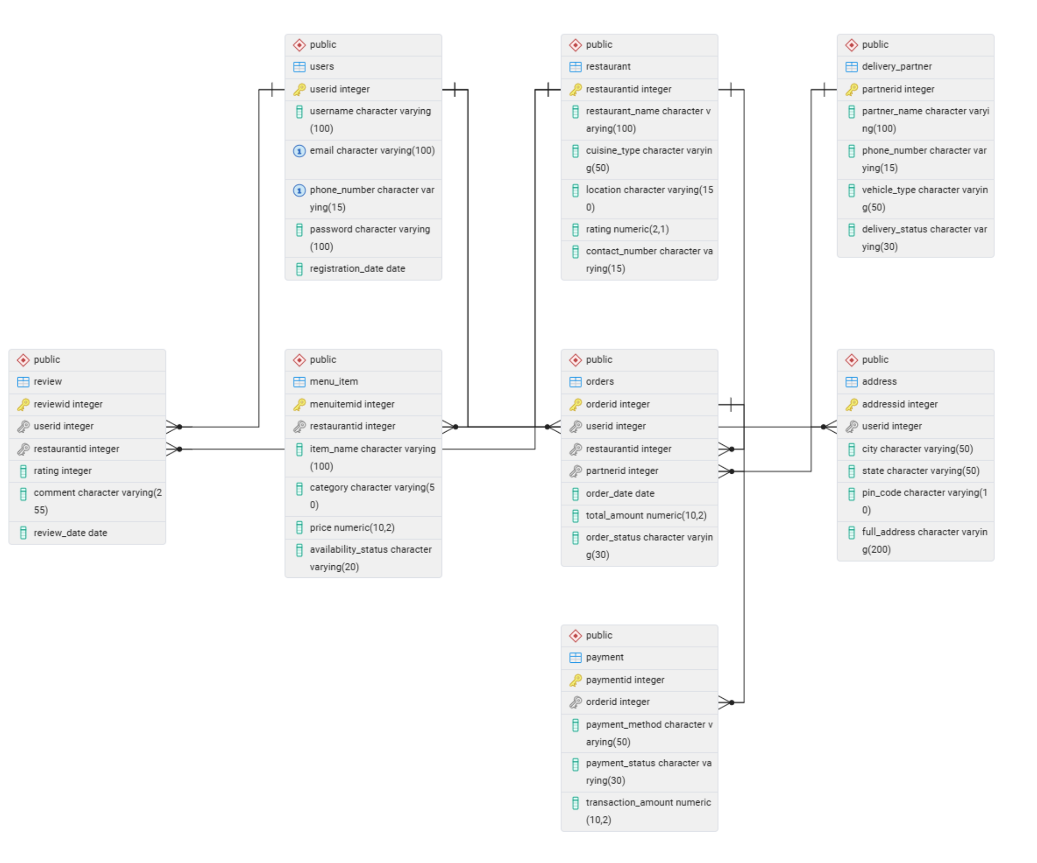

Conclusion :

The ER diagram of Swiggy successfully represents the relationships between major entities involved in the food delivery ecosystem. The design ensures proper data organization, minimizes redundancy, and maintains data integrity through primary and foreign key relationships. By connecting users, restaurants, orders, payments, delivery partners, reviews, and addresses, the database structure supports efficient order management, delivery tracking, payment processing, and customer interaction, making the system scalable and effective for real-world operations.

